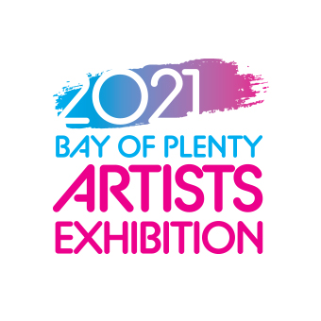
Artists Submission Form – Must be submitted with image by 17 Sept 2023: to Julie.parsons@rotorualc.nz
Name:

Address:

Email:

Phone 1: Phone 2:

Title of work 1: | Title of work 2:
Date of production:  Medium: | Date of production:  Medium:
Size of artwork:  3D (Width x Height x Depth): _______________  Or 2D (Width x Height_____________________ | Size of artwork:  3D (Width x Height x Depth): _______________  Or 2D (Width x Height_____________________
Price including 30% commission: | Price including 30% commission:
Declaration:
- I have read and accept the conditions of entry as above including delivery and uplifting of works.
- I declare the work is my own and does not infringe upon NZ copyright laws.
- I agree to the reproduction of the work in any publicity material (including online) for the purposes of this and subsequent exhibitions.

Signed ________________________________________Date ____________________________

Attach image of artwork:
Please attach an image of your completed artwork to the email with this submission form. Image must be over 1MB.

Important Dates:
- Call for Artists: Submission forms due 17 September 2023
- Delivery of works: From Saturday 9 September, Sunday 8 October 2023 –see below
- Exhibition Opening (artists & guests): Sunday 22 October 2023
- Exhibition (open to the public):
Monday 23 October – Sunday 10 December 2023, 10am – 4pm weekdays 2pm to 4pm weekends
- Collection (unsold works): By 4pm, Sunday 17 December 2023

Conditions:
- Artworks can be in any art or craft medium but will not include audio, digital or moving images
- Artists must currently reside, work or study in the Bay of Plenty, or be students who study away from their Bay of Plenty home base
- There is no entry fee for the BOP Artists Exhibition
- Artists are invited to submit up to two works only. Due to limited space all works may not be selected
- Acceptance of work will be at the sole discretion of the Friends of Rotorua Museum
- Works must not infringe on New Zealand copyright laws
- The work must be the sole work of the artist - unless it is submitted as a collaboration
- All works must be for sale and the sale price must include commission of 30%
- Works will be photographed and used for promotional purposes including social media and print

Works must be ready to hang/display:
- Hanging works must come complete with strong cord or wire affixed, flat ‘D’ attachments and detailed hanging instructions
- Loose canvas work must come with pins for hanging
- Hanging works must not exceed 15kgs
- Freestanding works must not exceed 750mm in any direction
- Freestanding works must not exceed 20kgs

All works must:
- Have dry, secure surfaces
- Be labelled with the artists name, address, contact phone number, title, date of production, medium and price including commission

Delivery of Works:
- Works are accepted for delivery from Saturday 9 September, Sunday 8 October 2023
- Weekdays, deliver between 8.30am – 4.30pm to:
  - Attn: BOP Artists Exhibition, Lockwood Homes, 8 Russell Road, Rotorua
- Weekends, deliver between 1pm – 4pm to:
  - Attn: BOP Artists Exhibition, Lockwood Showhome Village, 43 Fairy Springs Road, Rotorua

Unsold Works:
- Unsold works must be uplifted from Lockwood Homes by Sunday 17 December 2023 (unless prior arrangement has been made)
- Unsold works that need to be returned by courier are at the cost and organisation of the artist
- All entries not uplifted by this date will become the property of Friends of Rotorua Museum

Insurance:
- Insurance is the sole responsibility of the artist, while the work is in transit and during exhibition.
- All reasonable care will be taken in the handling and showing of works, but no liability for loss or damage will be accepted by Friends of Rotorua Museum, Lockwood Homes, or their members or staff.

For further information contact: Julie Parsons, 027 242 4132, 07 351 7823, Julie.parsons@rotorualc.nz

